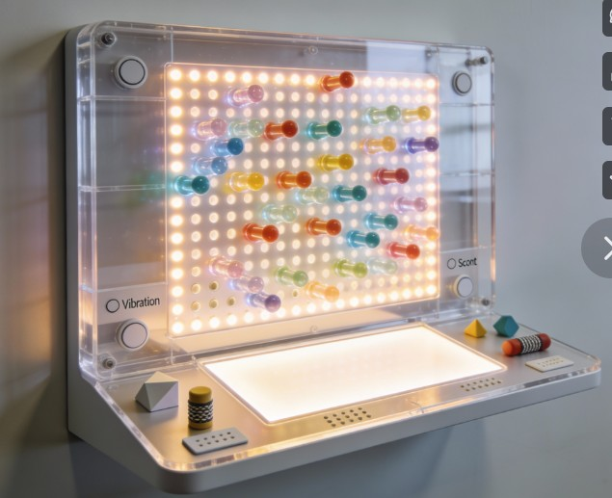

Sensory Symphony
  - Clinical justification
Cherris Christensen | Inventor

Clinical Justification Sheet

- Sensory Symphony Discovery Center (SSDC Unit)

- Purpose
- The SSDC Unit is a multisensory therapeutic system specifically designed to support adults with sensory, intellectual, and developmental disabilities. It integrates tactile, visual, auditory, and haptic pathways to promote regulation, communication, engagement, and functional participation.

- Clinical Rationale
- Adults with sensory processing differences often experience dysregulation, limited communication pathways, and difficulty sustaining engagement. Research on multisensory environments (MSEs) shows that structured sensory input can:
- Reduce anxiety and agitation
- Improve emotional regulation
- Increase participation in therapy
- Support communication attempts
- Enhance sensory processing
- Improve readiness for learning and movement
- The SSDC Unit provides these benefits through predictable, user-directed sensory interaction.

- Evidence Summary
- Primary Evidence Source
- Yi YJ, Matin NH. Perception and experience of multisensory environments among neurodivergent people: systematic review. Architectural Science Review. 2025. doi:10.1080/00038628.2025.2462569
- This systematic review highlights that neurodivergent adults benefit most from multisensory environments that offer:
- Predictable, calming sensory input
- User-controlled sensory intensity
- Non-verbal, exploration-based engagement
- Multimodal sensory pathways (visual, tactile, auditory)
- Reduced sensory overload and improved emotional regulation
- These findings directly support the SSDC Unit’s multisensory design.

- Supporting Evidence (Searchable Studies)
- Emotional regulation: “multisensory environment adults developmental disabilities emotional regulation study”
- Reduced challenging behaviors: “multisensory environment adults IDD scoping review occupational therapy”
- Multisensory learning & neuroplasticity: “multisensory learning neuroplasticity adults cognitive processing”

- Discipline-Specific Benefits
- Occupational Therapy (OT)
- Supports sensory modulation, fine-motor coordination, bilateral hand use, visual-motor integration, and adaptive responses.
- Speech-Language Pathology (SLP)
- Enhances receptive language, joint attention, intentional communication, auditory processing, and cause-and-effect learning.
- Physical Therapy (PT)
- Promotes upper-extremity reach, grasp, postural alignment, visual tracking, and sensory-motor integration.
- Applied Behavior Analysis (ABA)
- Provides immediate sensory reinforcement, predictable contingencies, reduced escape-maintained behaviors, increased engagement, and data tracking.

- Clinical Summary Statement
- The SSDC Unit is a multisensory therapeutic system that provides structured tactile, visual, auditory, and haptic input to support sensory regulation, communication, engagement, and functional participation in adults with sensory processing challenges and intellectual/developmental disabilities. Its design aligns with evidence-based practices across OT, SLP, PT, and ABA.

